spiegelspel

[Company name]  [Company address]

HOw to start up keycloak on openshift

1. Login from openshift in your command line using the oc login command
2. Enter this command in the namespace you want to deploy keycloak in

“oc process -f https://raw.githubusercontent.com/keycloak/keycloak-quickstarts/latest/openshift/keycloak.yaml -p KEYCLOAK_ADMIN=admin -p KEYCLOAK_ADMIN_PASSWORD={Your Password} -p NAMESPACE=keycloak | oc create -f –“

1. Go to your keycloak server login using the credentials you entered
2. Create a realm called speigelspelA screenshot of a computer

   Description automatically generated
3. Go to Realm roles create 2 realm roles superadmin and user

1. Create a client called “spiegelspel” make sure that the client secret can be accessed

1. Make sure client authorization, authentication and authorization flow(standard flow, implicit flow and oauth) is checked

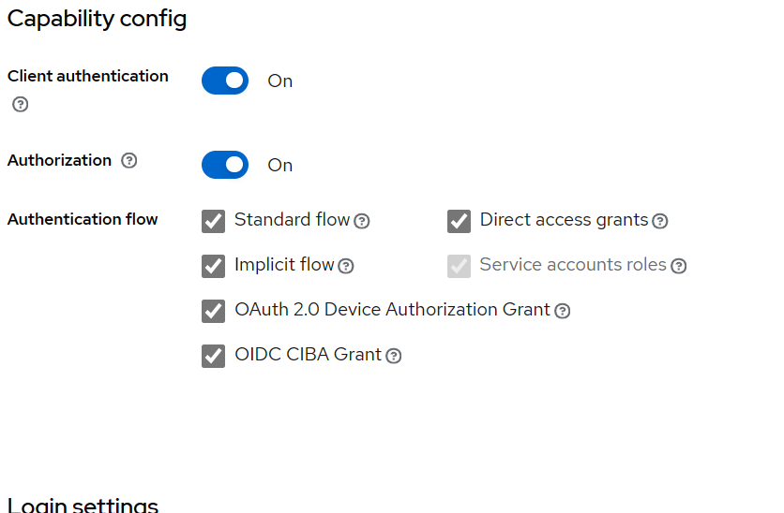

1. Go to users on the side bar create an user called admin and add a password to the user
2. Under user admin role-mapping assign all the roles for admin including the two roles that we created

